Appendices

Appendix 1



### Appendix 1: Consolidated Results Table for all the 24 study sites

Appendix 2



Appendix 2: Shows all the Analytics of EID Program Review at 6 Regional Referral Hospitals

Appendix 3

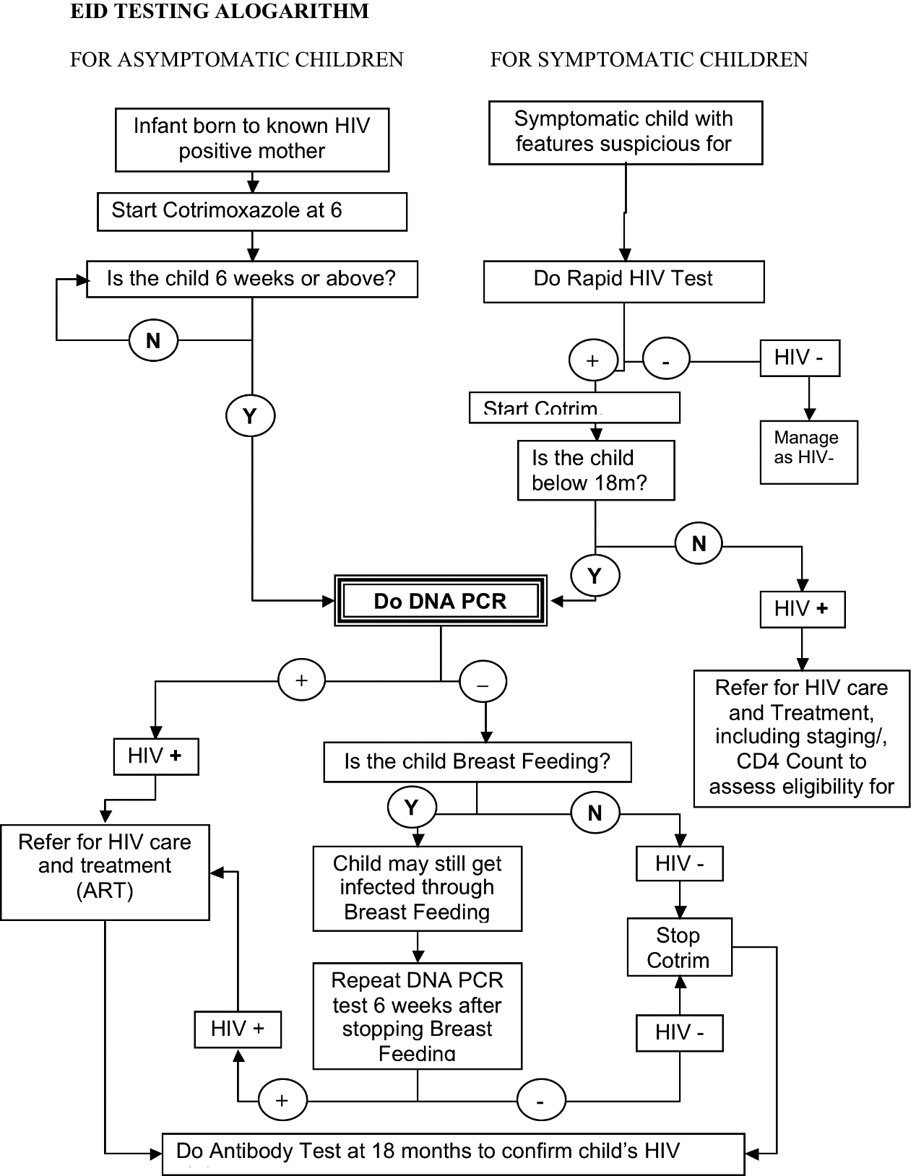

Appendix 3: EID testing algorithm